Remote Access VPN

*Self-Signed Certificates*

Adv Cisco Cybersecurity – Lab 10

Jason Liu

Cybersecurity – Mr. Mason & Mr. Hansen

Period 5

*Lab 10: Palo Alto Remote Access VPN with Certificates*

**Purpose**

The purpose of this lab is to set up a remote access VPN using a Palo Alto firewall. Self-Signed Certificates are used on the client and firewall as the main method of authentication.

**Background Information**

A VPN or virtual private network creates a secure and encrypted tunnel between the user’s device and the network which prevents unwanted interception of data. Remote access VPNs are commonly used by businesses and organizations to enable employees or students to access resources and applications from remote locations. This allows for work to be done while people are working from home or travelling. Because of the encryption, sensitive information cannot be obtained by external network security threats.

A remote access VPN is a type of network that allows a user to securely connect to a network, such as a corporate network from a remote location using the WAN of the internet as the medium of transport.

Compared to site-to-site VPNs, remote access VPNs are used to connect to a network from a private, remote site such as one’s home, while site-to-site VPNs are used to connect two or more private networks together. Palo Alto firewalls use a VPN software called GlobalProtect for setting up a remote access VPN. GlobalProtect is client-based and can be used for a variety of platforms including Windows, macOS, iOS, and Android.

This lab was configured using a self-signed certificate to establish a secure connection. A certificate is a digital document that is used to authenticate a device. The certificate usually contains information such as the owner’s name, public key, and other identifying information. Certificates are usually issued by a trusted third party but in this lab, we created our own certificate. Other options exist such as a pre-shared key (legacy option) or SSL. SSL or Secure Sockets Layer is a security protocol that used a combination of asymmetric and symmetric encryption to secure a connection.

The main benefits of a remote access VPN is that the firewall can be accessed anywhere as long as the GlobalProtect connection can be authenticated and established via the internet, regardless of location. This is all the while the private tunnel encrypts sensitive data. Drawbacks and weakness are due to the fact it is a single point of failure, making it vulnerable to DoS attacks, and the accessibility becomes a weakness due to insecure endpoints and lack of visibility to monitor traffic from other devices on the network. For some VPNs, the lack of user access monitoring means users often have too many permissions and can tamper with existing settings. However, through all of this, Remote Access VPN still provides a strong and safe tool to access your firewall and navigate the internet securely.

**Lab Summary**

In this lab, a remote site PC connects to the firewall via the internet. Using the VPN service of Global Protect and its client software, a valid portal and gateway configuration using the following IPs will create a secure VPN connection. The sole purpose of PC0 is for the management interface for the firewall. Generating a self-signed certificate along with SSL/TLS and user profile creation, the global protect VPN tunnel can be properly formed. The connection will then be established. Other IPs if configured and updated correctly will also lead to the same result. When both ends have GlobalProtect software installed (one using the firewall and the other using the connection), a GlobalProtect portal application can monitor the status of the client’s VPN connection.

**Network Diagram with IPs**

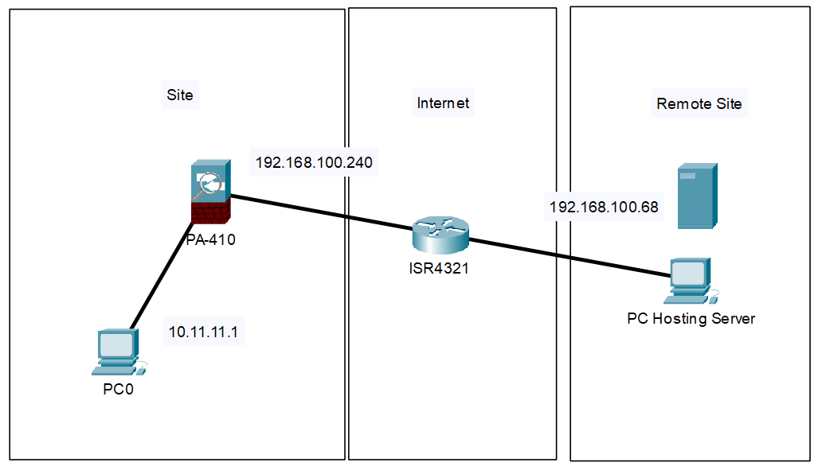

The Remote Site’s PC is the outside user. PC0 acts solely as the device that configures the firewall via the MGMT interface.

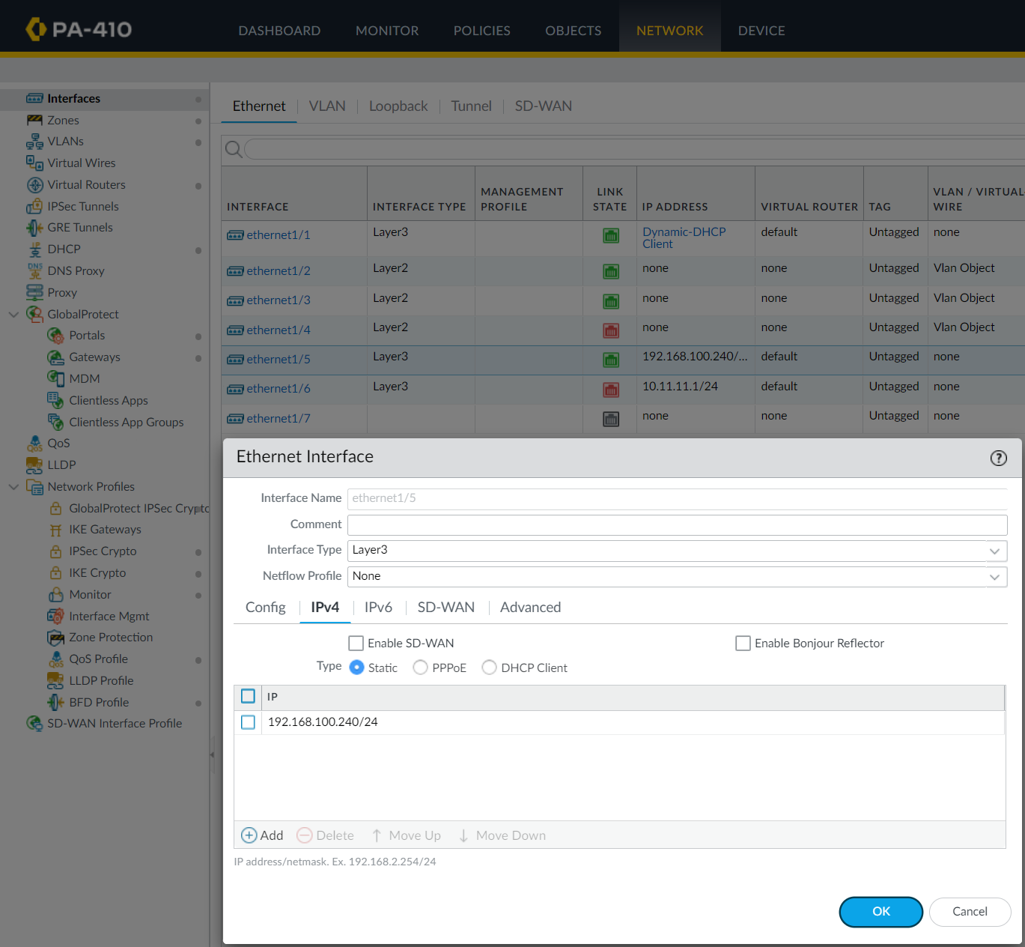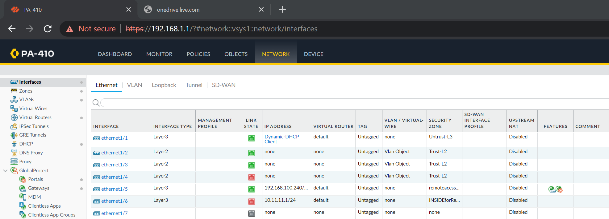**Procedure**

The IP address of 192.168.100.240/24 was used for the outbound interface. This statically assigned address is the main outbound interface. Remote sites point to this address.

New outbound interfaces were configured for the purpose of the VPN. Interface ethernet 1/5 was used as the outbound. 1/6 was used for SOHO that connects to the MGMT port.

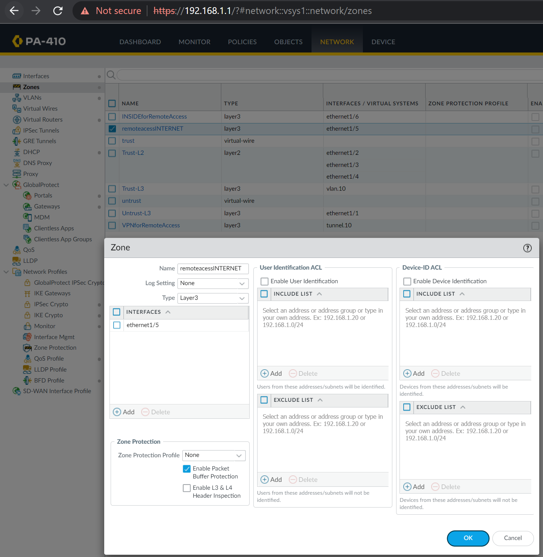

New zone is created for the outbound interface. This L3 zone allows connection to the internet.

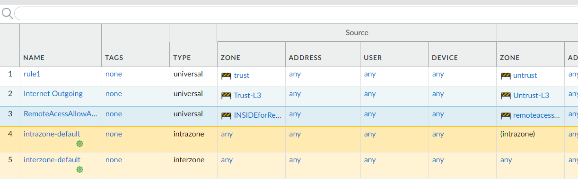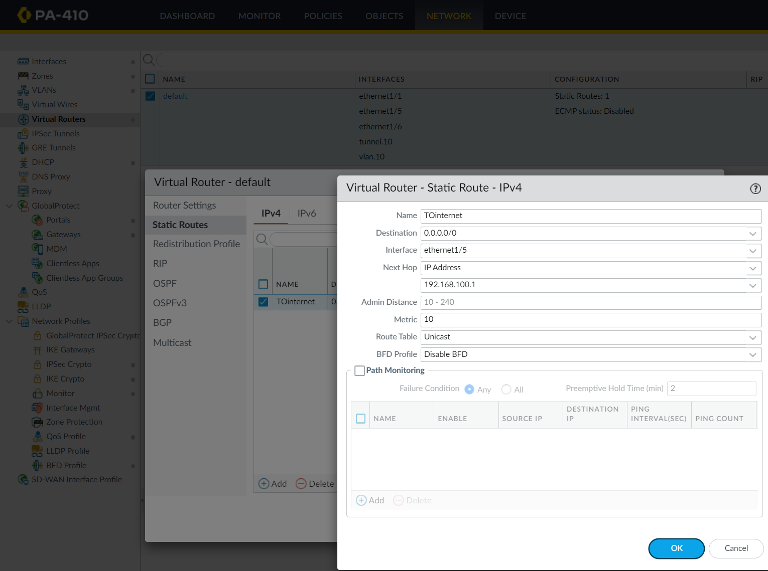

Security Policies are created for the zones to interact with each other.

This static route allows the address to route to the internet because of the default route of 0.0.0.0/0.

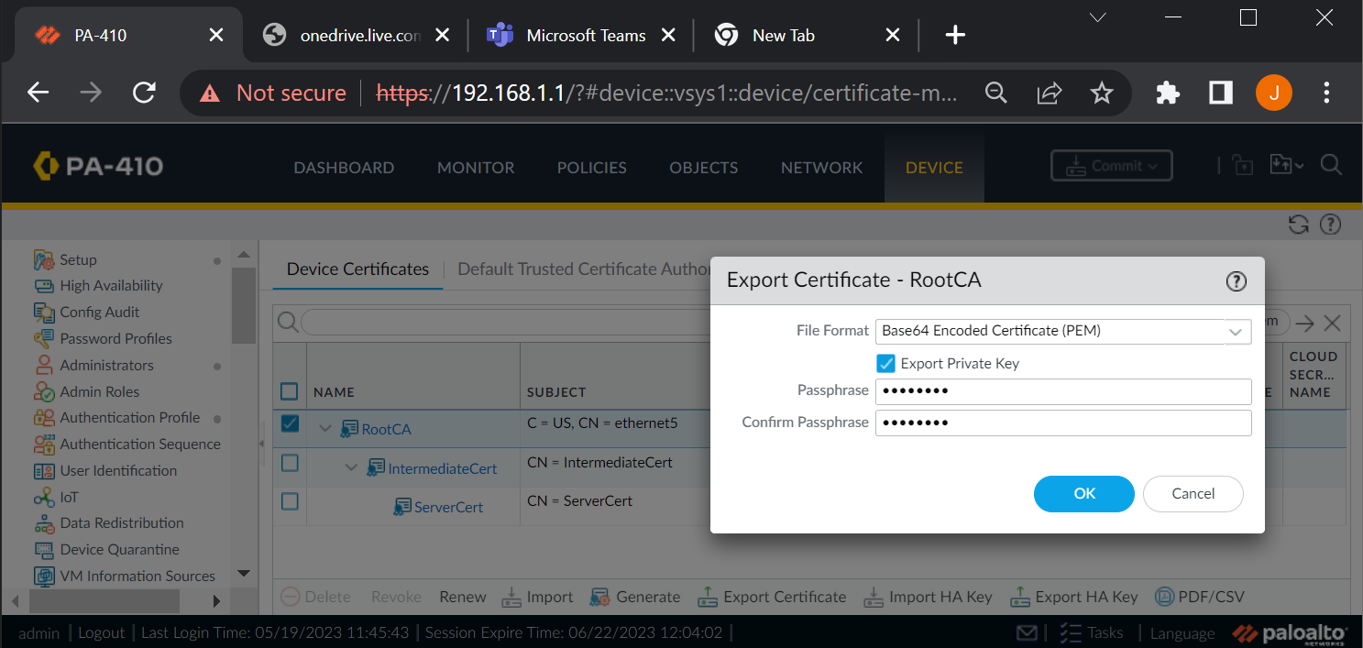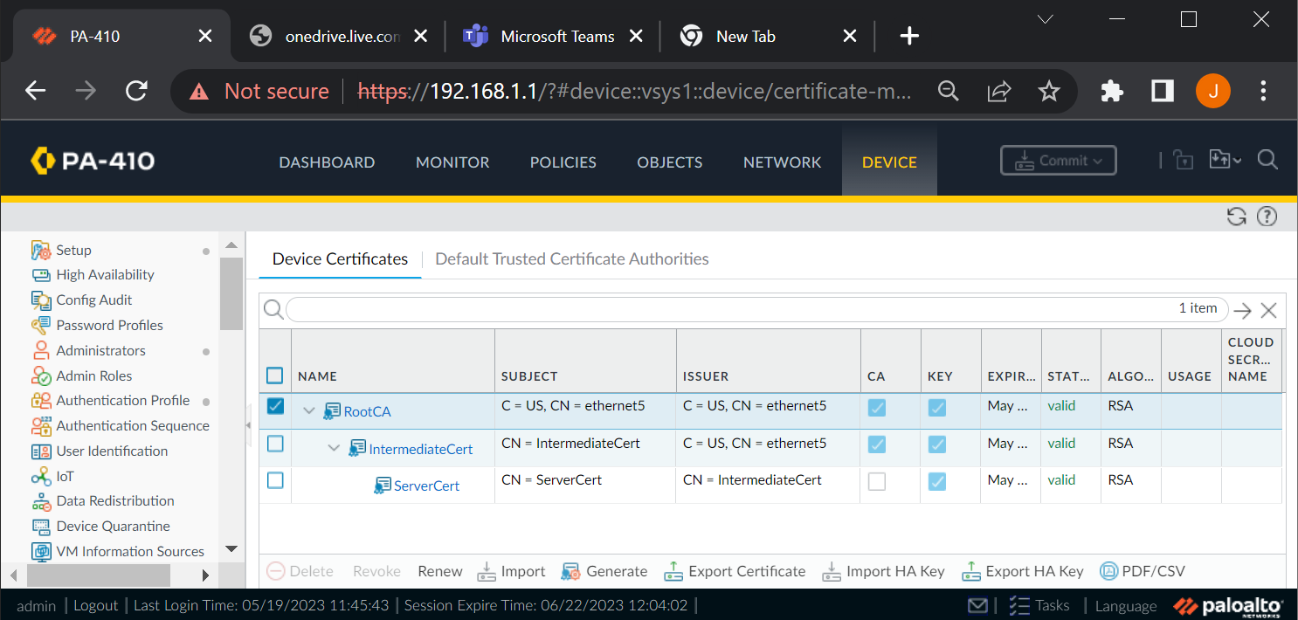

Certificate authorities are created in tiers for scalable best practice.

Export the certificate as a PEM file with the Private Key.

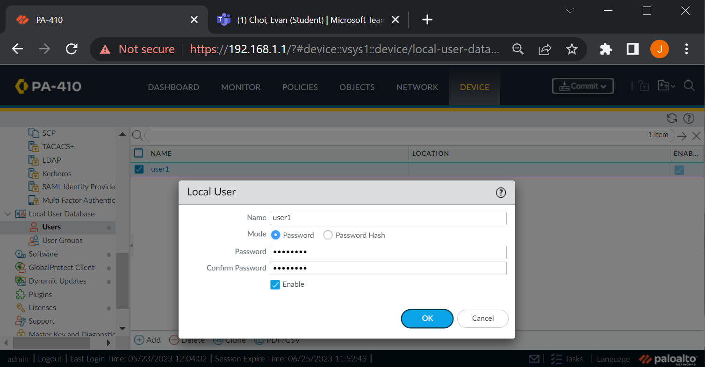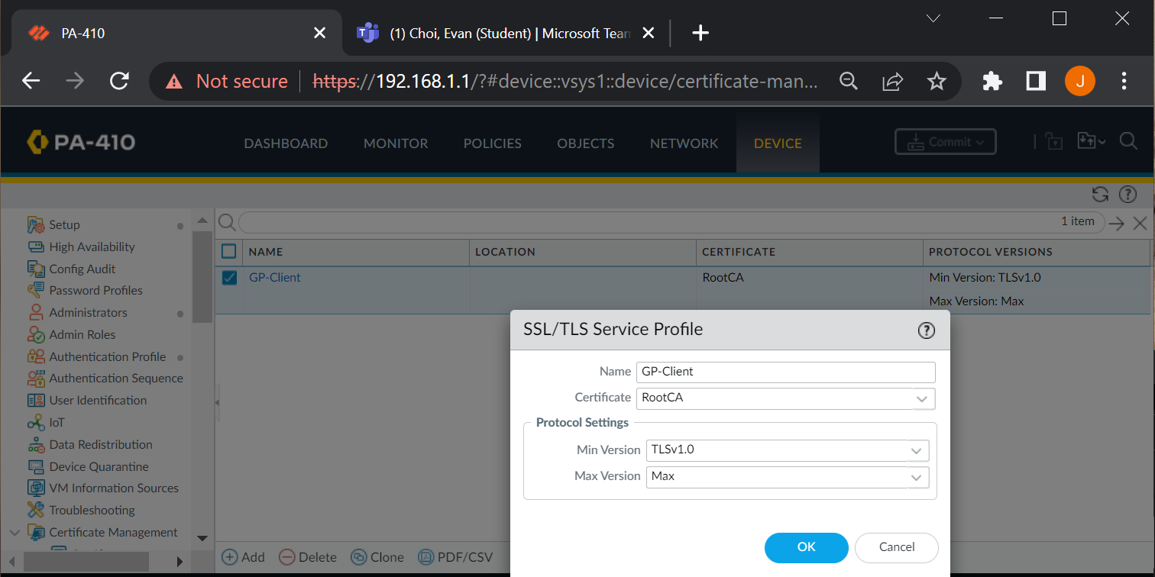

Create a SSL/TLS Profile with the certificate and a TLS version of 1.0.

Create a user. This is the local user and password used for GlobalProtect Portal login.

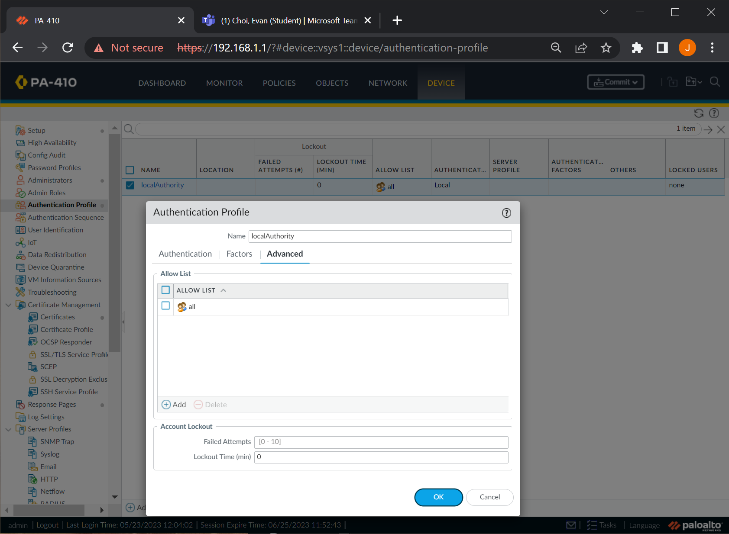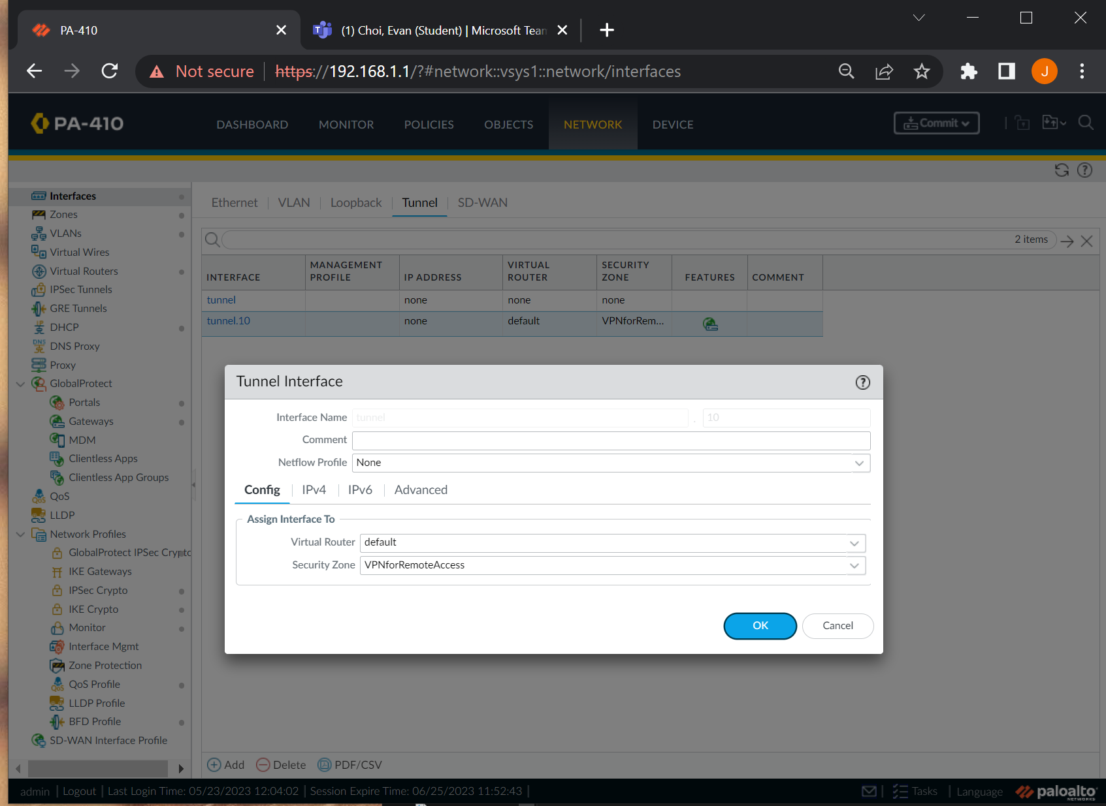

Create a tunnel interface for the VPN under the Security Zone created for the Remote Access VPN.

Create an authentication profile that authenticates and allows all users.

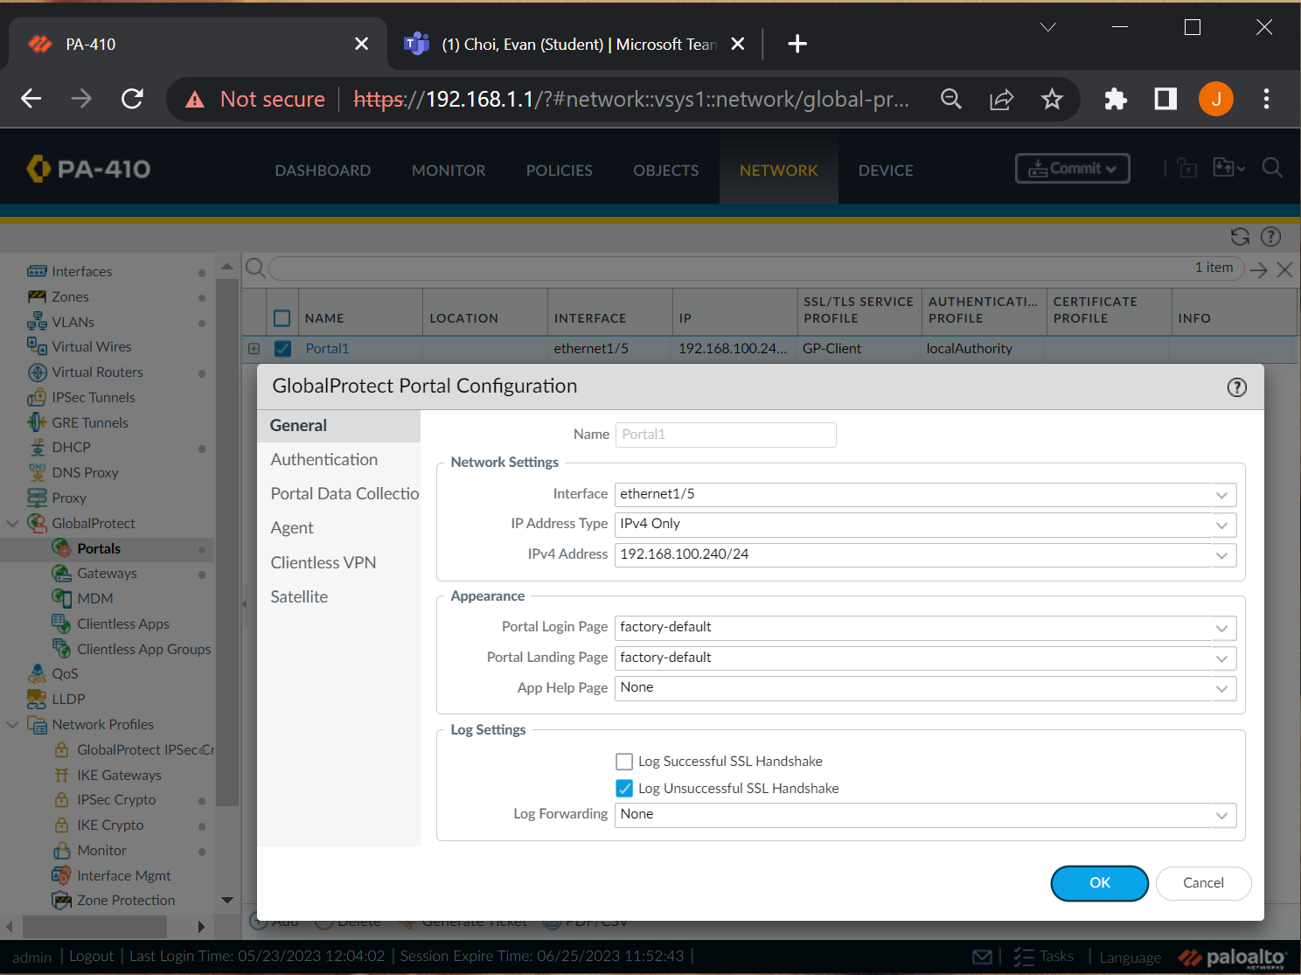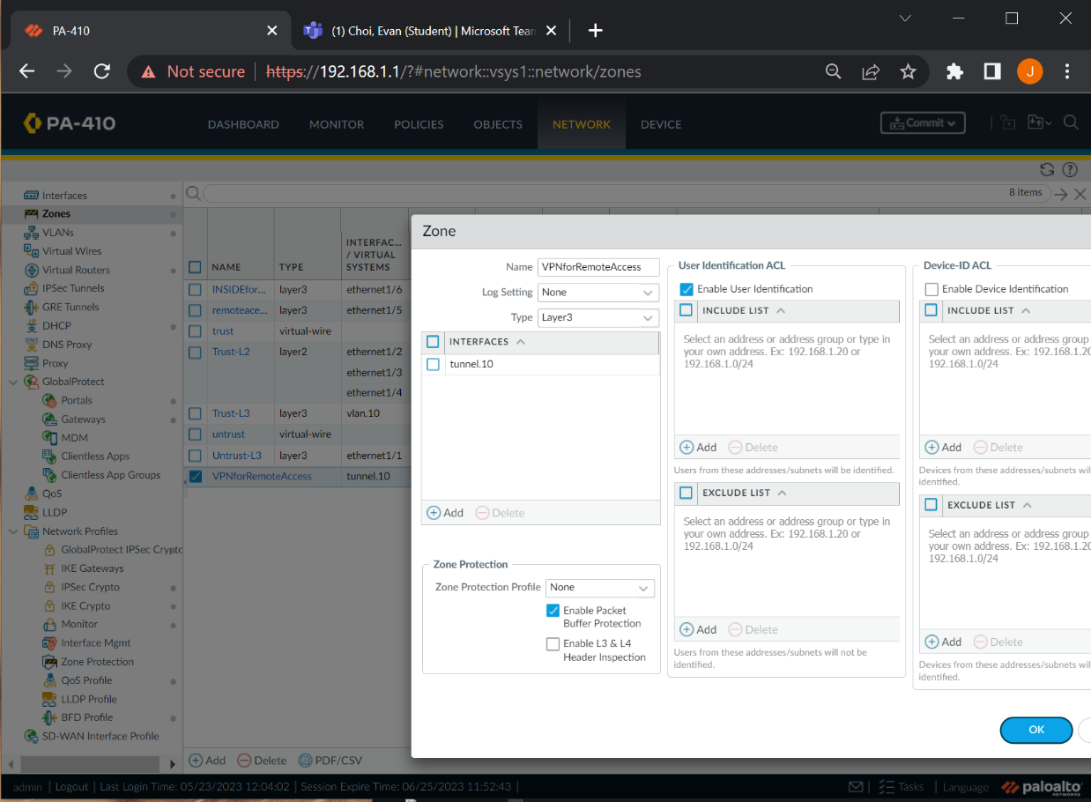

Configure the GlobalProtect Portal Configuration with the corresponding outbound IP address and port.

Create a VPN zone for the tunnel interface.

Assign the tunnel interface to the newly created zone.

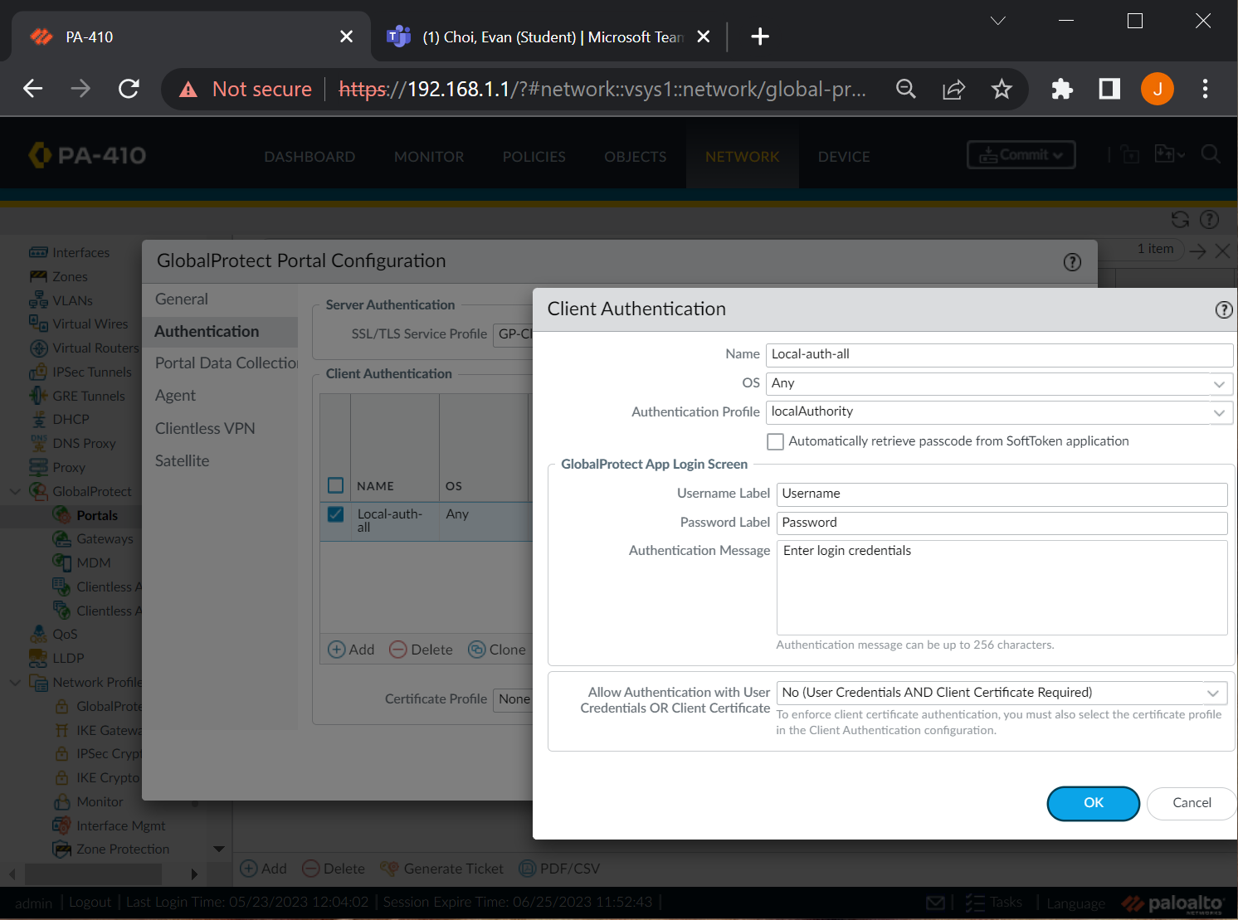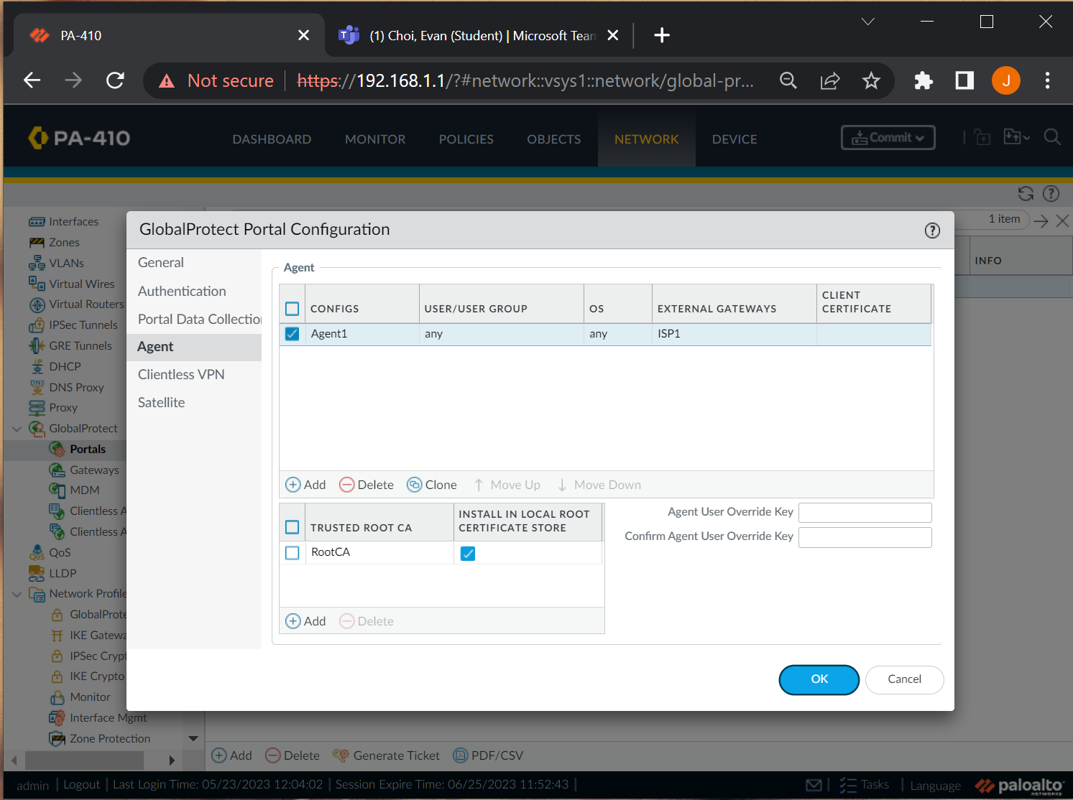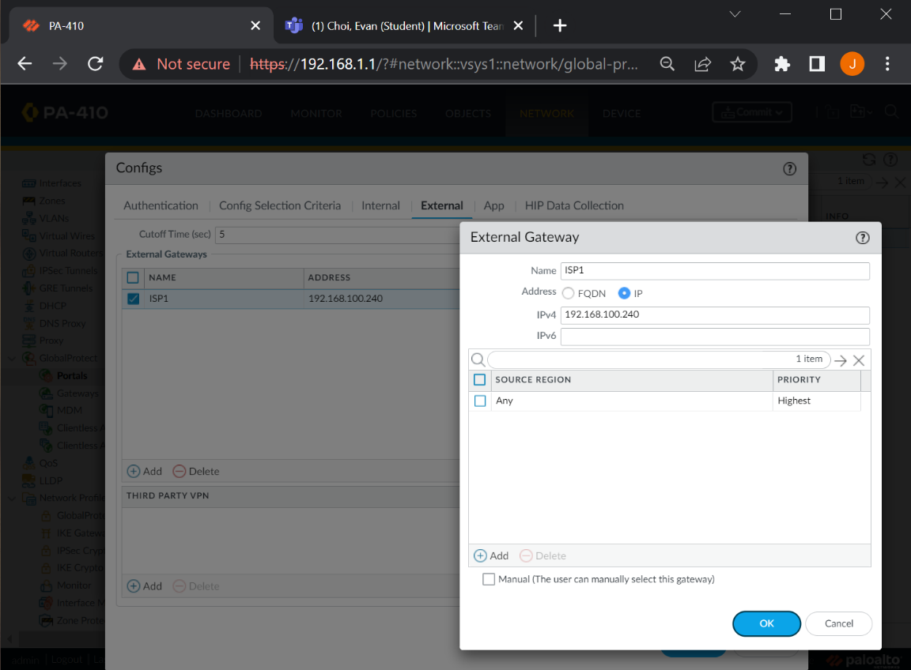

Under GlobalProtect Gateway > external, use the IP of the outbound as gateway IP.

Use the created authentication profile for the client authentication of the portal.

Configure the agent in the portal configuration and select the corresponding certificate.

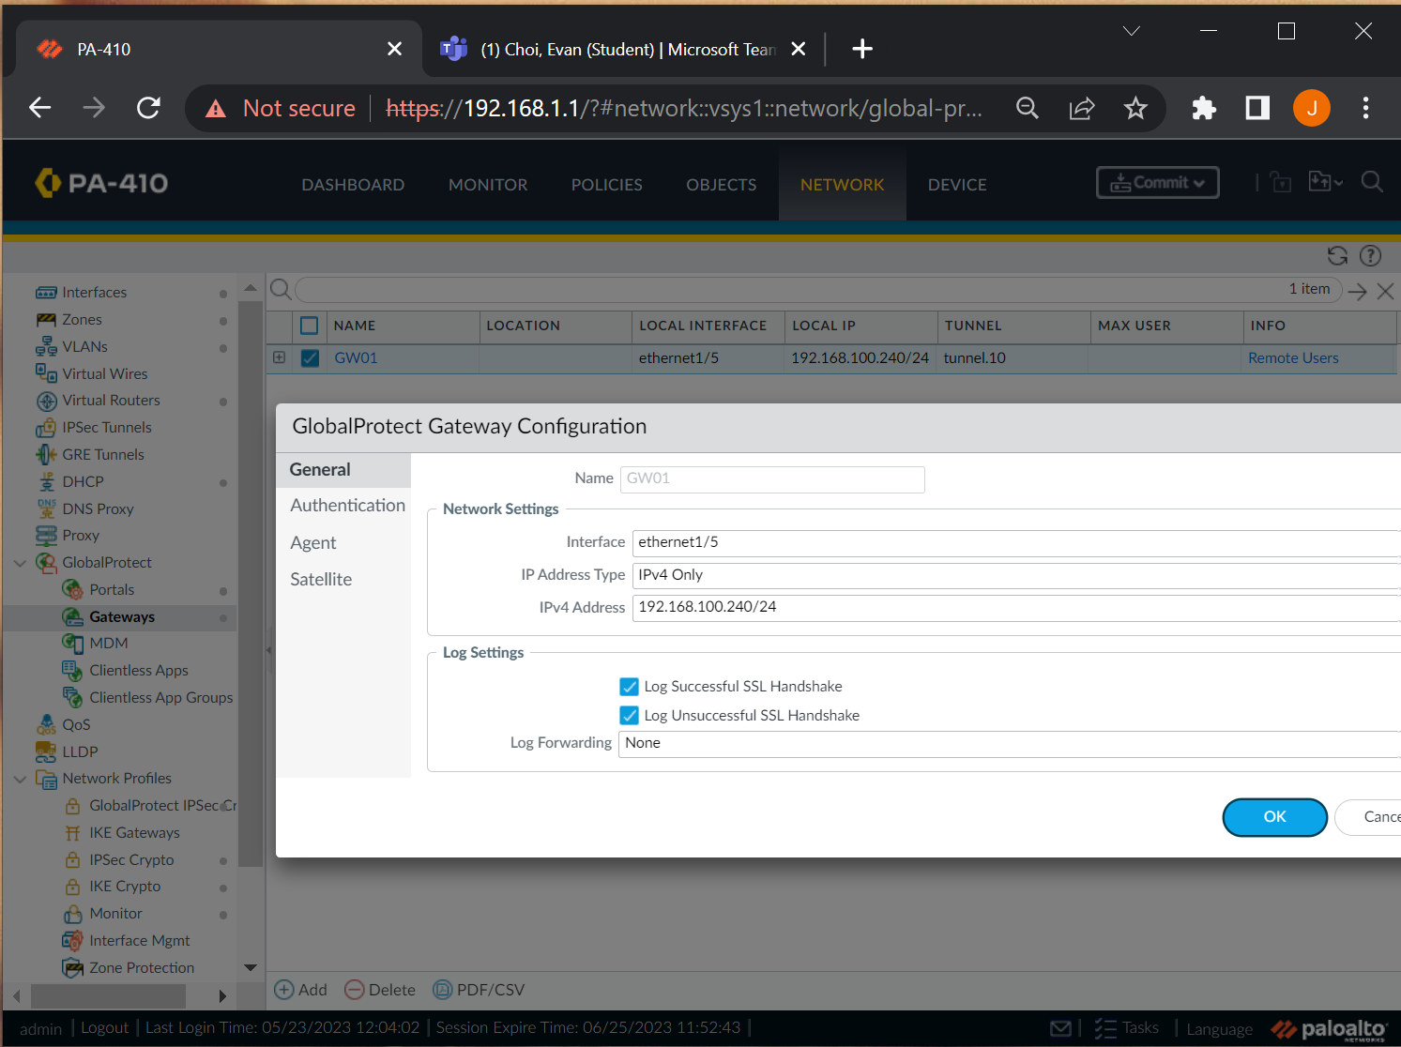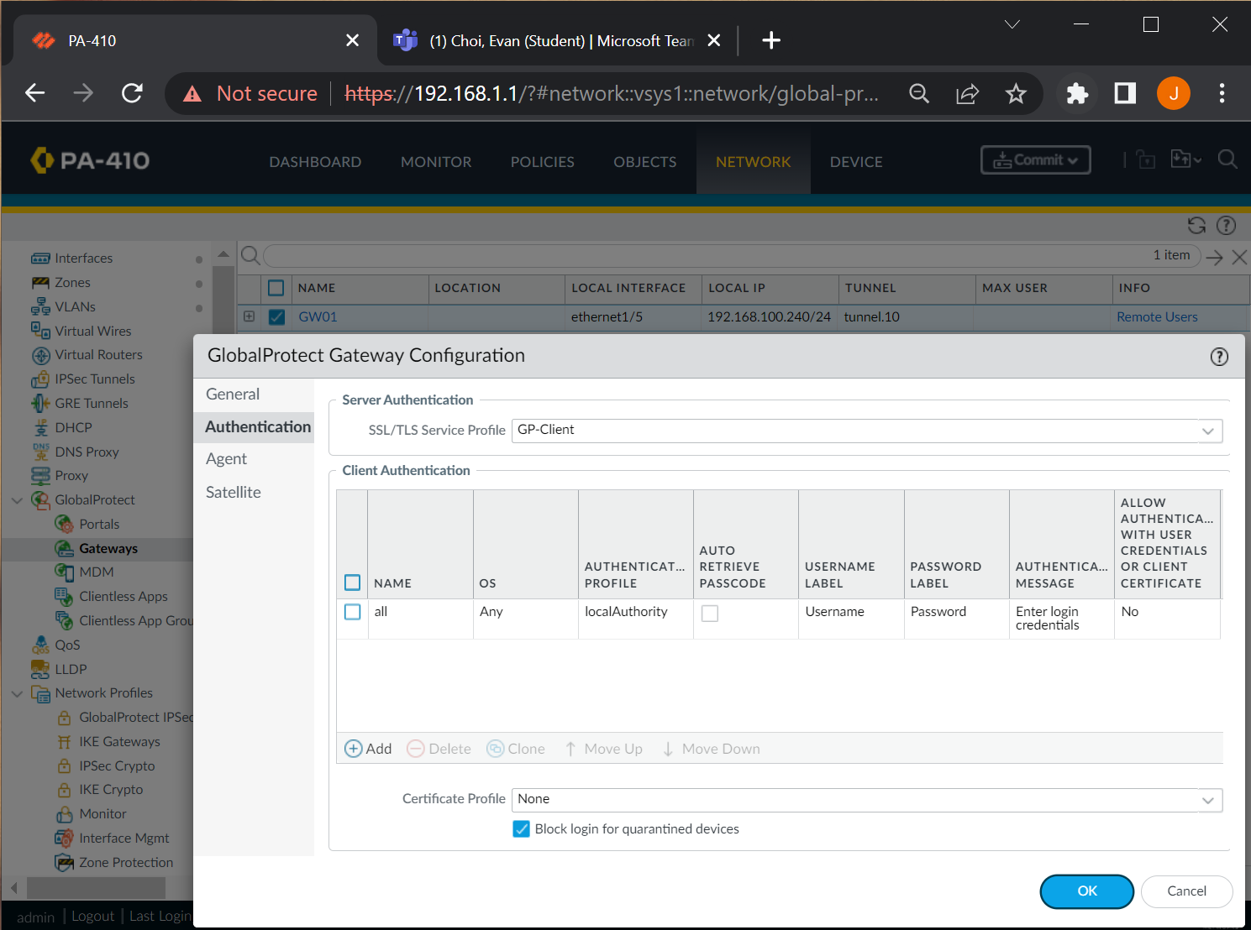

Create a client authentication.

Now using the created tunnel interface, the local interface, and the local IP, finish the GlobalProtect Gateway Configurations.

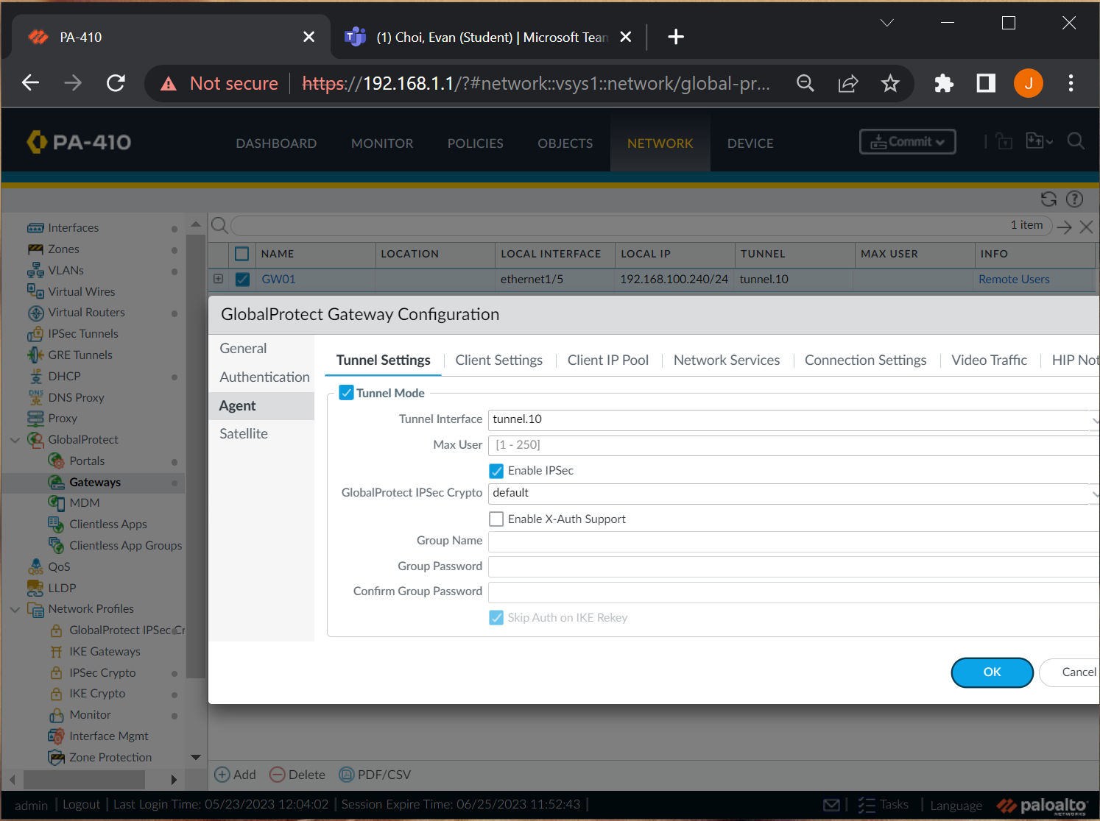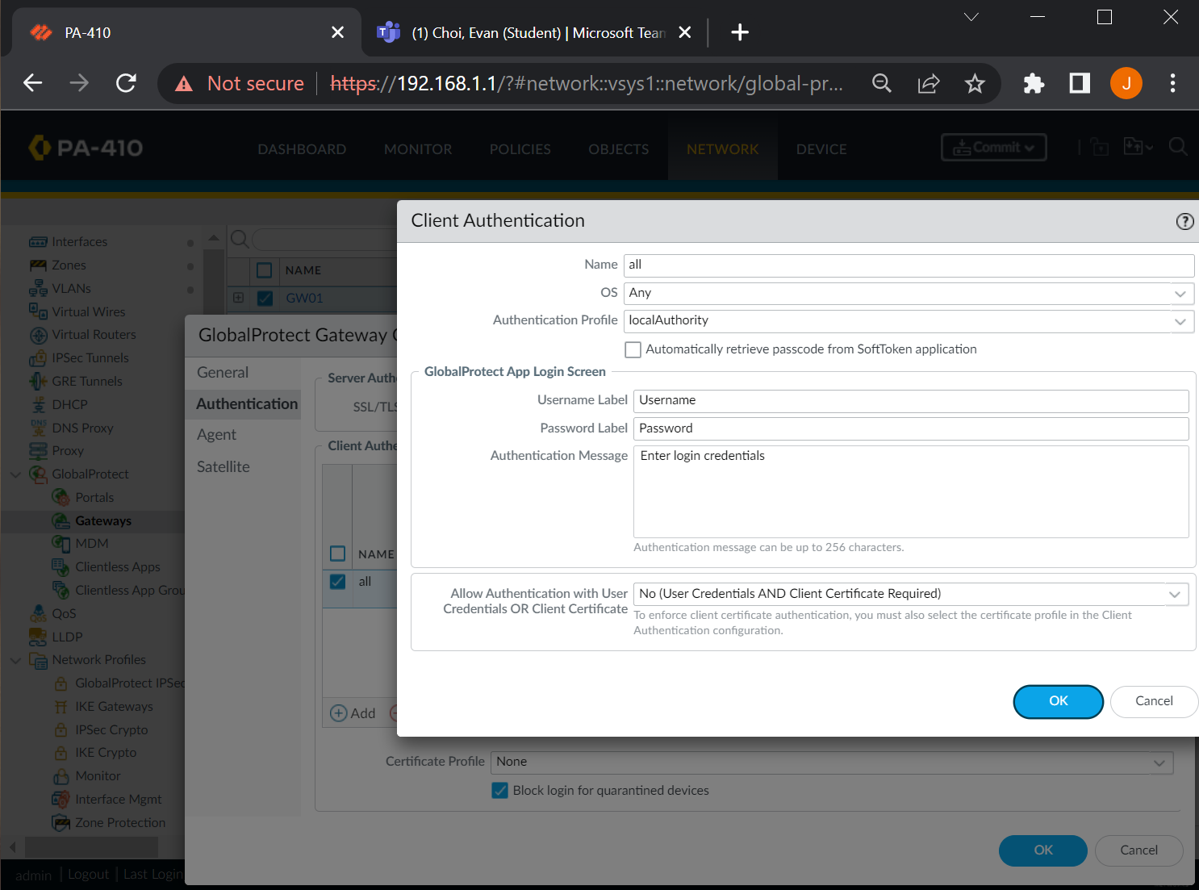

Configure the tunnel settings of this gateway tab to use the VPN tunnel interface you created earlier.

This is the client authentication configuration.

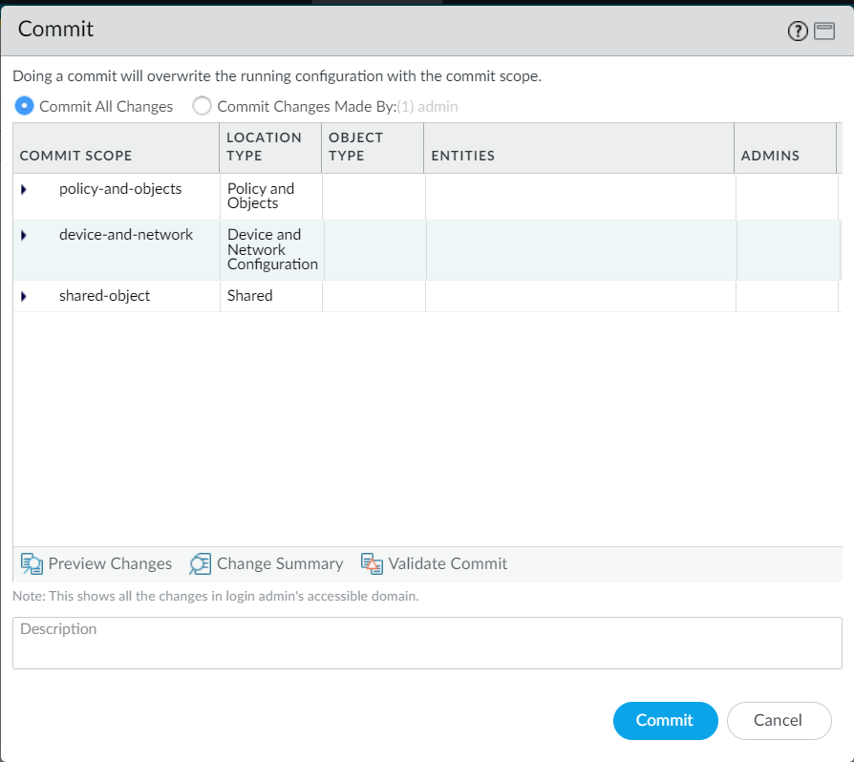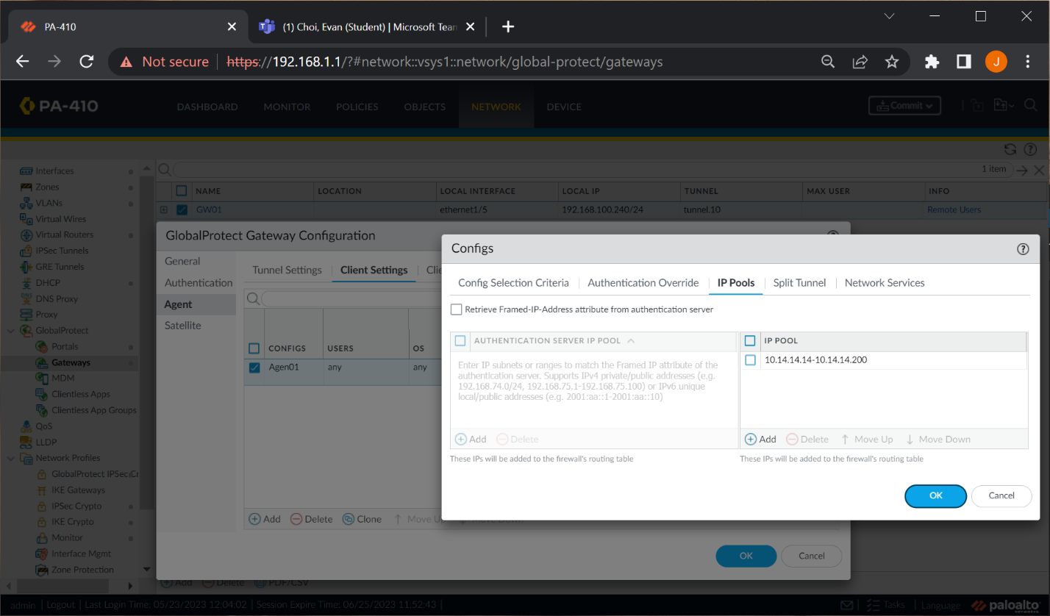

Commit all changes.

Define an IP pool that clients using the VPN can be assigned when connected to the VPN.

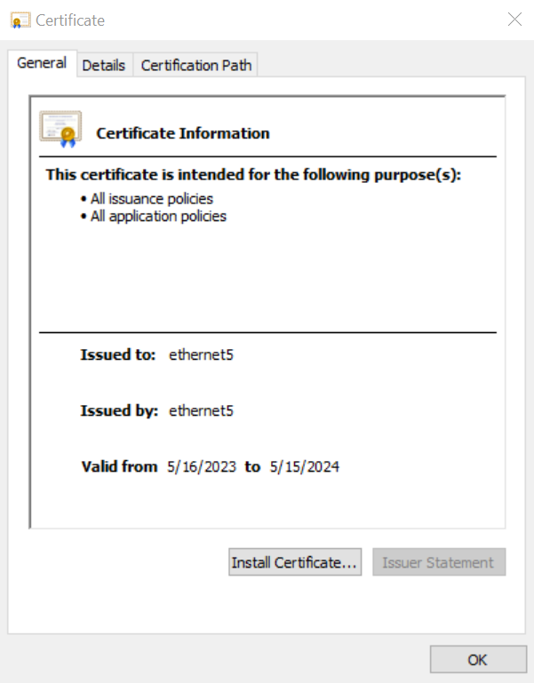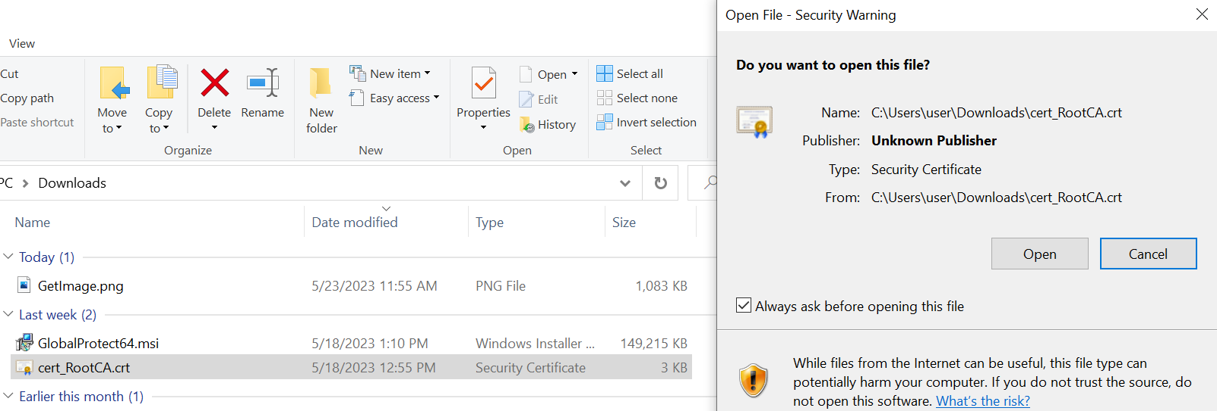

Double check the information of the imported certificate and install it.

On the remote site’s user PC, rename the PEM file to a .crt file. Open the file. Windows will be able to read it as a certificate.

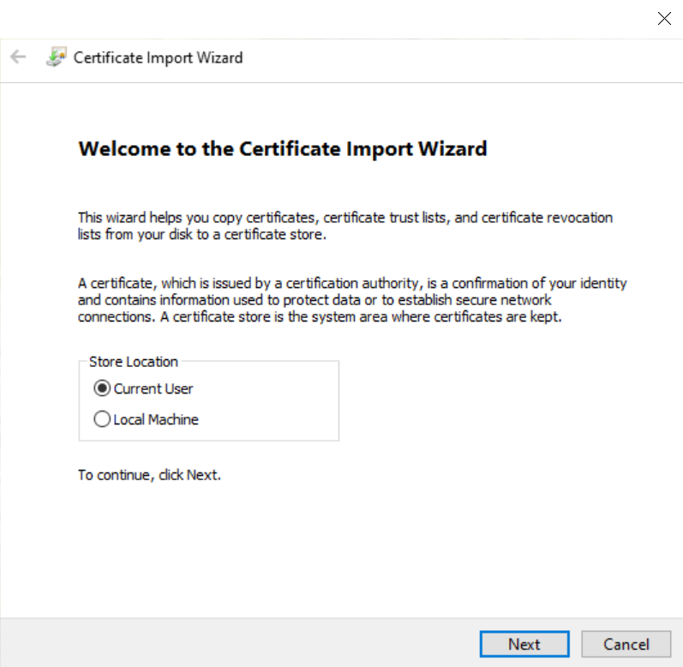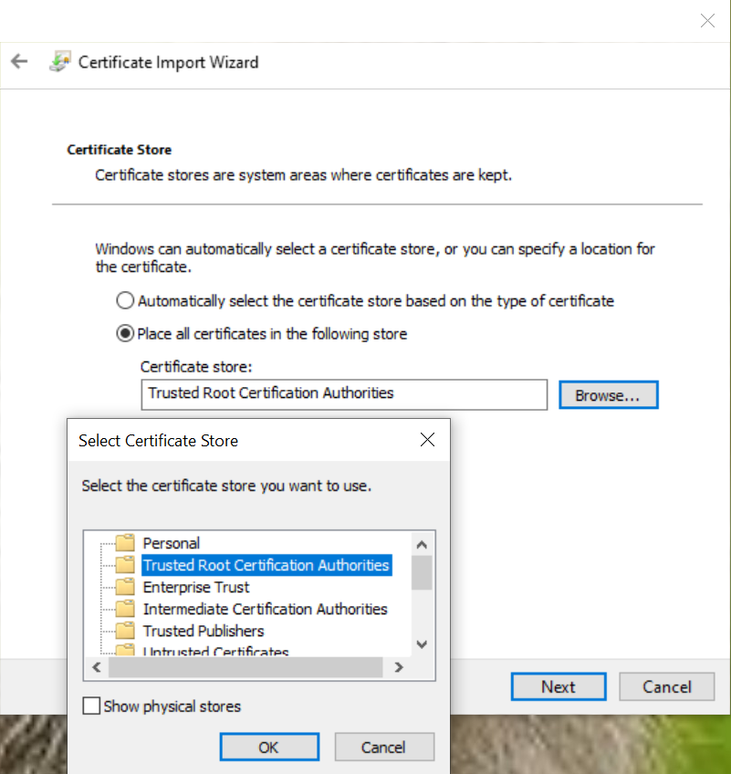

Import the certificate onto the remote site’s device. This certificate will be the form of authentication. It counts as a trusted root certification authority.

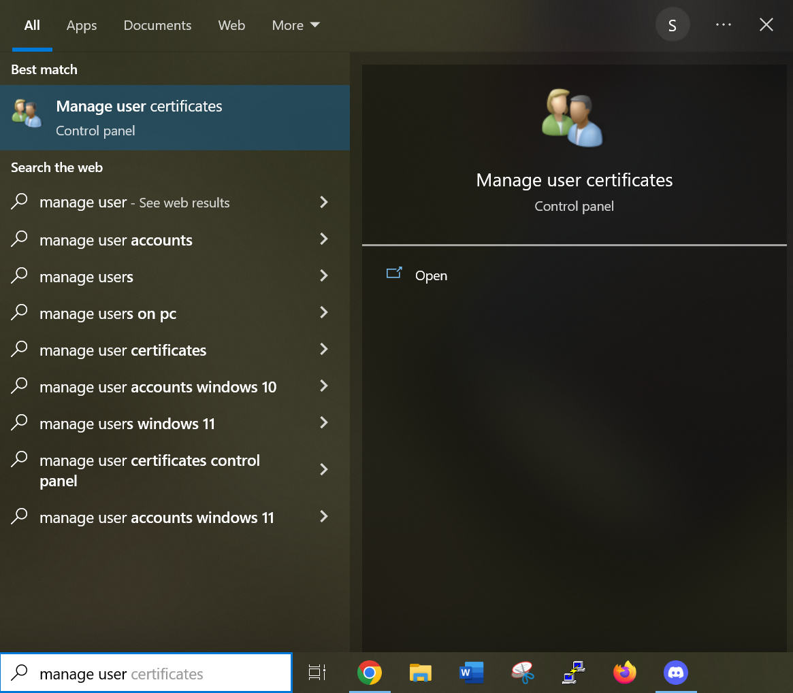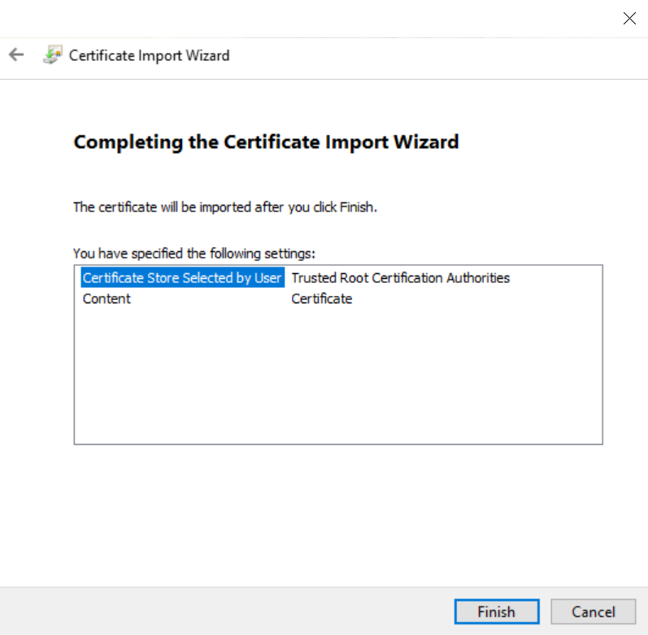

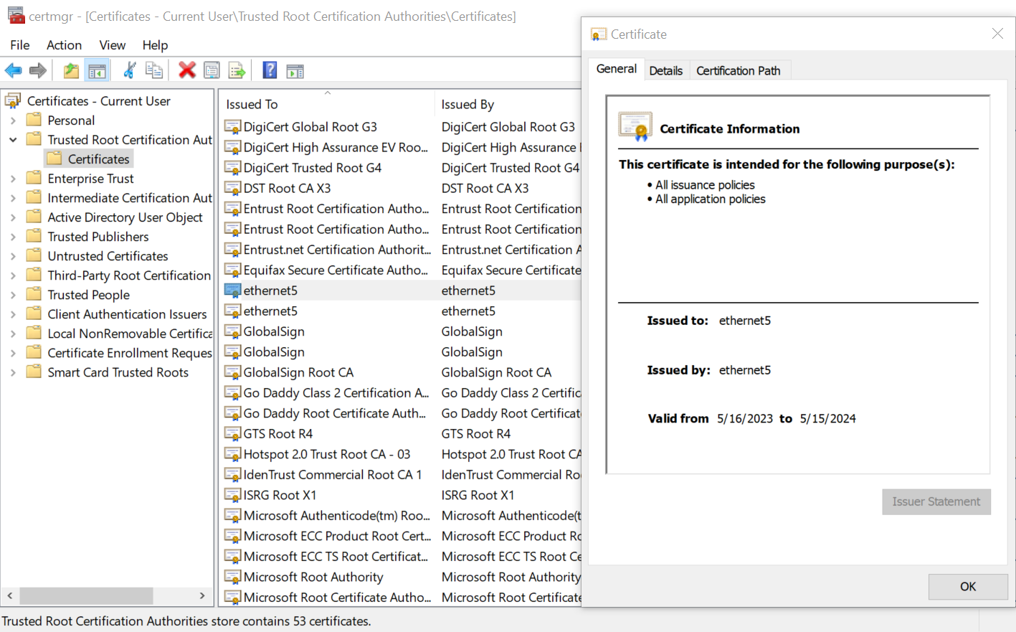

Check that the certificate is properly imported under “manage user certificates.”

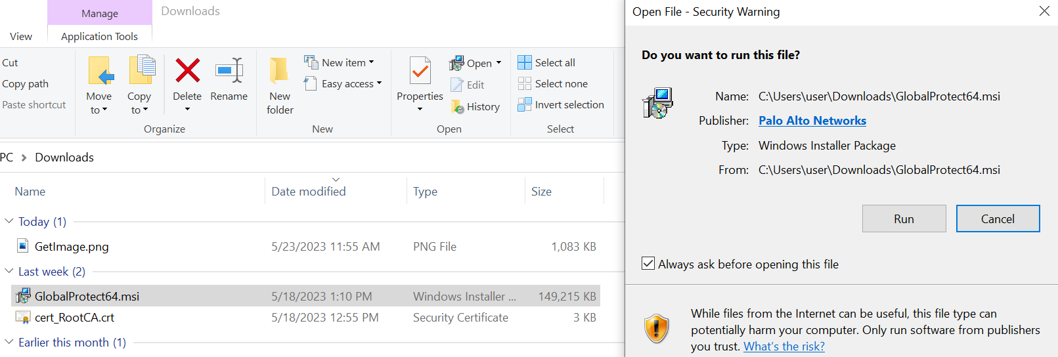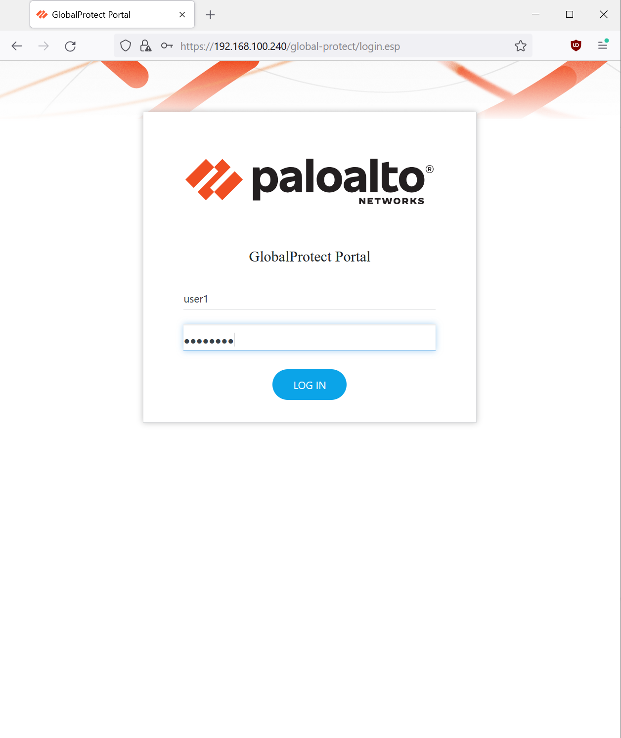

The web browser should then lead you to a GlobalProtect portal application installation link. Run the installer to download the app.

From the remote PC, connected to the WAN that the firewall is connected to, access the 192.168.100.240 outbound address from a web browser. Firefox was used. Enter in the user profile information created earlier on the firewall.

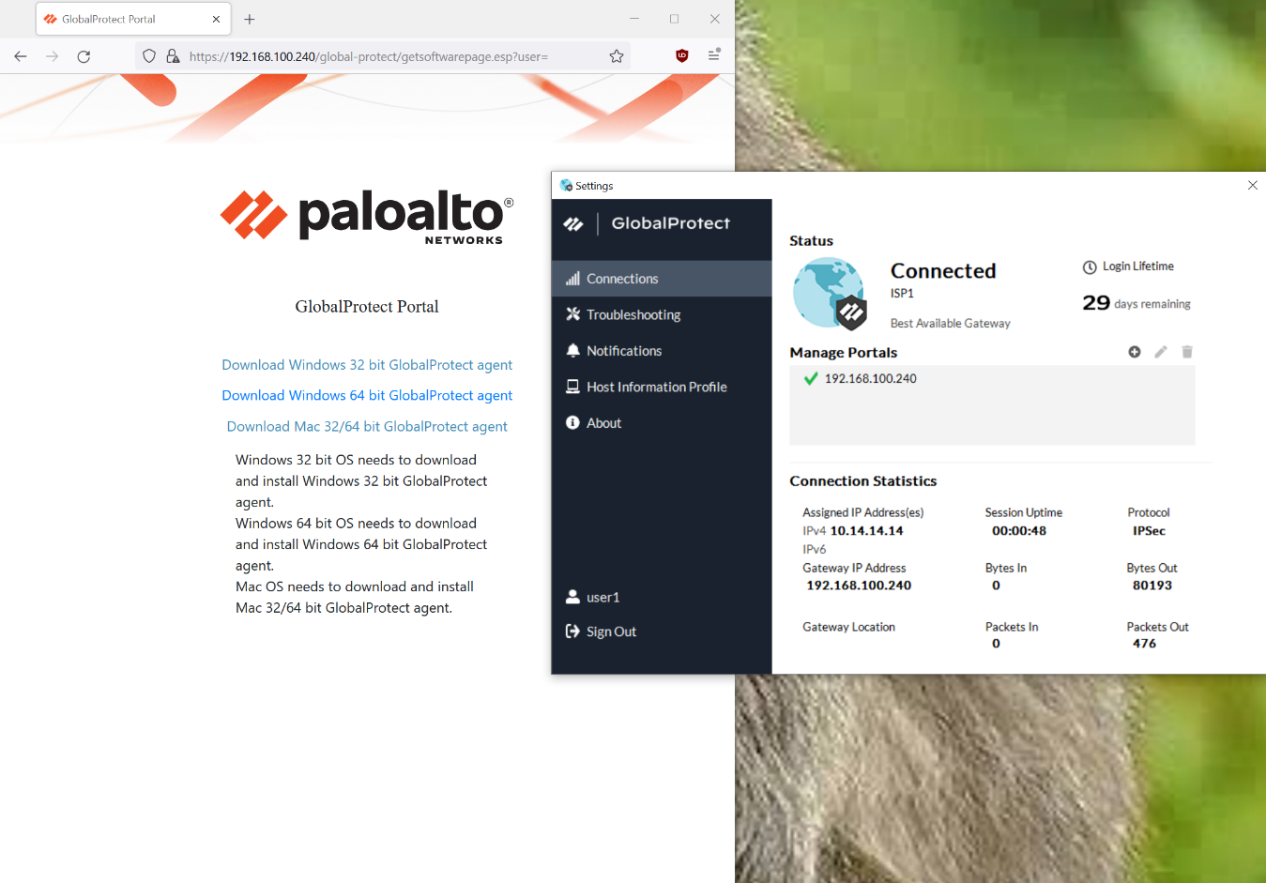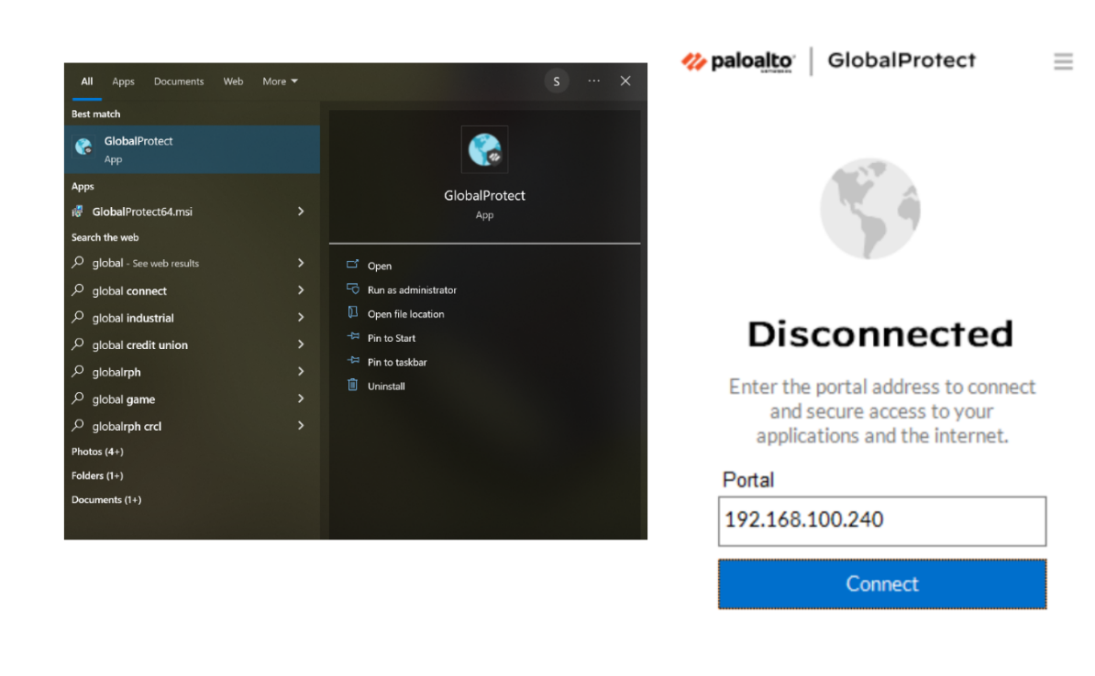

Open the app and enter the portal gateway address. This is the outbound interface address used throughout the lab. Once connected, connection details are shown.

The VPN connection can be monitored on this application.

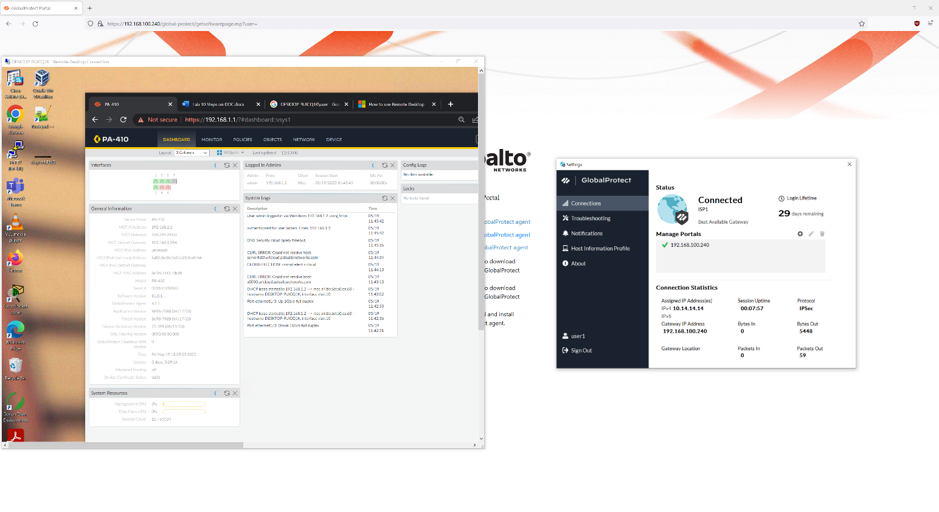

As proof of the connection being established, remote desktop was used to gain control of the computer used for the Management Interface, inside the site. This means that the outside PC connected to the firewall and it’s SOHO via the Internet.

**Problems**

Many of this lab’s issues arose from the lack of proper understanding of the IP scheme and the VPN configuration as a whole. For example, we would confuse the management interface port with the outbound interface port for SOHO or mix the IPs. Other times, we either forget to connect to the internet, or the rack port or wire have physical issues and create many points of inconsistency. Such examples of this would be how a client ported into the SOHO of the firewall allows me to connect to the internet, and then after changing IPs, changing wires, discussing troubleshooting and other elements of the lab, and then changing back to the same configurations and using the same ports, my PC’s access to the internet via the SOHO has been inhibited. After a while, not changing any scheme, it would work. Sometimes, the connection would flicker and would repetitively connect and disconnect. Using my lab partner’s computer, the connection would be consistent. Physical issues with the rack, which is pre-made to connect to the PC’s, hindered consistency with both this lab and the simultaneous lab, Lab 11 – *Remote Access Clientless VPN*. It made it hard to determine whether a configuration worked or not. It is further highlighted when we did complete the lab, and reattempting the same IP scenario the next day, the replicated attempt failed. After a while of confused waiting, the lab worked and GlobalProtect could be accessed. We imply from this that Palo Alto’s GlobalProtect must take a while for configurations to boot.

Another issue was the software update. Firewalls should be properly licensed as we searched for updates, but I accidentally skipped from version 10.2 to 11.0.1 directly. This jump is too big and not typically best practice. It was a surprise that it did work though, and as I researched on why it happened. It used to be that software versions can only handle so many versions at a time, and thus requires slow version by version updating. However, according the PAN-OS release notes, <https://docs.paloaltonetworks.com/pan-os/11-0/pan-os-release-notes/features-introduced-in-pan-os/management-features#idf9a23a17-24d7-4d7e-b7bb-216bd885cbc3>, the new management feature of skip software version was just updated to skip up to 2 major releases and one minor release. This allows us to quickly use the latest PAN-OS tools such as those of GlobalProtect. Dynamic Updates can be updated without this issue.

Other issues include: Under Portal > Agent, we tried to use a common name, IQDN, instead of an IP address. It is later than important that the IP address is referred to for the GlobalProtect connection to be established, as it is the IP address that is being authenticated and passed into the software. We made the address the 192.168.100.240 gateway. For the certificates, it is best practice to have an intermediate root authority (RA) as well, along with the root and server certificate. It is simply another RA under the main root authority. Branches allow scalability for security. Lastly, for GlobalProtect to work, not only does it have to be installed, but it must also be activated on the dynamic updates screen.

**Conclusion**

Dealing with remote access VPNs involved a lot of IP tracking for the client devices with only 2 computers per rack. Past this, the configuration was straightforward and completely GUI-based due to its reliance on GlobalProtect portals and gateways. Ultimately, learning this skill was an important and nuanced experience in my VPN journey. For the future, we want to explore the full extent of GlobalProtect’s VPN services as well as other VPN options.